MODOC LAFCO

DAPHNEDALE
Community Services District

Sphere of Influence

Adopted
April 10, 2012

Resolution 2012-0001
TABLE OF CONTENTS
1 INTRODUCTION . . . . . . . . . . . . . . . . . . . . . . . . . . . . . . . . . . . . . . . . . . . . . . . 1
1.1 LAFCO's Responsibilities . . . . . . . . . . . . . . . . . . . . . . . . . . . . . . . . . . . 1
1.2 Sphere of Influence Requirements . . . . . . . . . . . . . . . . . . . . . . . . . . . . 1
1.3 Possible Approaches to the Sphere of Influence . . . . . . . . . . . . . . . . . 2
1.4 SOI Update Process . . . . . . . . . . . . . . . . . . . . . . . . . . . . . . . . . . . . . . 3
1.5 SOI Amendments and CEQA . . . . . . . . . . . . . . . . . . . . . . . . . . . . . . . . 4

2 DAPHNEDALE CSD SPHERE OF INFLUENCE . . . . . . . . . . . . . . . . . . . . . . 5
2.1 Present and Planned Land Uses in the Daphnedale Area, Including
Agricultural and Open Space Lands Land Use. . . . . . 6
2.1.1 Land Use in the Daphnedale CSD Area. . . . . . . . . . . . . . . . 6
A. Modoc County General Plan Designations . . . . . . . . . 6
B. City of Alturas General Plan Designations . . . . . . . . . 6
2.1.2 SOI Determinations Present and Planned Land Use
For Daphnedale CSD . . . . . . . . . . . . . . . . . . . . . 6
2.2. Municipal Services: Present Need . . . . . . . . . . . . . . . . . . . . . . . . . . . 7
2.2.1 Service Need for Daphnedale CSD . . . . . . . . . . . . . . . . . . . . . 7 2.2.2 SOI Determinations for Facilities and Services: Present and Probable Need . . . . . . . . . . . . . . . . . . . . . . . . . . . . . 7
2.3 Public Facilities Future Capacity . . . . . . . . . . . . . . . . . . . . . . . . . . . . . 7
2.3.1 Facilities and Capacity . . . . . . . . . . . . . . . . . . . . . . . . . . . . . . 7
2.3.2 SOI Determinations for Public Facilities
Present and Future Capacity . . . . . . . . . . . . . . . . . . . 7
2.4 Social or Economic Communities of Interest . . . . . . . . . . . . . . . . . . 8
2.4.1 Daphnedale CSD . . . . . . . . . . . . . . . . . . . . . . . . . . . . . . . . . 8
2.4.2 SOI Determinations for Social or Economic
Communities of Interest . . . . . . . . . . . . . . . . . . . . . . . . 8

Sphere of Influence Map – City of Alturas 9

1 INTRODUCTION

1.1 LAFCO's Responsibilities

LAFCO’s in California are independent agencies created by the California Legislature in 1963 among whose major purposes include encouraging the orderly formation of local governmental agencies and conserving and preserving natural resources.

Statewide there are 58 LAFCOs working with nearly 3,500 governmental agencies (400+ cities, and 3,000+ special districts). Agency boundaries are often unrelated to one another and sometimes overlap at random, often leading to higher service costs to the taxpayer and general confusion regarding service area boundaries. LAFCO decisions strive to balance the competing needs in California for efficient services, affordable housing, economic opportunity, and conservation of natural resources.

LAFCOs are responsible for coordinating logical and timely changes in local governmental boundaries, conducting special studies that review ways to reorganize, simplify, and streamline governmental structure, preparing a review of services called a Municipal Service Review and preparing a Sphere of Influence thereby determining the future “probable” boundary for each city and special district within each county.

The Commission's efforts are directed toward seeing that services are provided efficiently and economically while agricultural and open-space lands are protected.

Often citizens are confused as to what LAFCO’s role is. LAFCO’s do not have enforcement authority nor do they have the authority to initiate a city or district annexation or detachment proceeding. LAFCO’s may initiate consolidation or dissolution proceedings; however, these proceedings are subject to the voter approval or denial.

The Legislature has given LAFCO’s the authority to modify any proposal before it to ensure the protection of agricultural and open space resources, discourage urban sprawl and promote orderly boundaries and the provision of adequate services.

1.2 Sphere of Influence Requirements

In determining the Sphere of Influence for each local agency, LAFCO must consider and prepare a written statement of determinations with respect to each of the following:

1. The present and planned land uses in the area, including agricultural and open space lands;

2. The present and probable need for public facilities and services in the area;

3. The present capacity of public facilities and adequacy of public services which the agency provides, or is authorized to provide; and

4. The existence of any social or economic communities of interest in the area if the commission determines that they are relevant to the agency.

1.3 Possible Approaches to the Sphere of Influence

LAFCO may recommend government reorganizations to particular agencies in the county, using the SOIs as the basis for those recommendations. Based on review of the guidelines of Modoc LAFCO as well as other LAFCOs in the State, various conceptual approaches have been identified from which to choose in designating an SOI. These seven approaches are explained below:

1) Coterminous Sphere:
A Coterminous Sphere means that the sphere for a city or special district that is the same as its existing boundaries. This is the recommendation for Daphnedale CSD.

2) Annexable Sphere:
A sphere larger than the agency’s boundaries identifies areas the agency is expected to annex. The annexable area is outside its boundaries and inside the sphere.

3) Detachable Sphere:
A sphere that is smaller than the agency’s boundaries identifies areas the agency is expected to detach. The detachable area is the area within the agency bounds but not within its sphere.

4) Zero Sphere:
A zero sphere indicates the affected agency’s public service functions should be reassigned to another agency and the agency should be dissolved or combined with one or more other agencies.

5) Consolidated Sphere:
A consolidated sphere includes two or more local agencies and indicates the agencies should be consolidated into one agency.

6) Limited Service Sphere:
A limited service sphere is the territory included within the SOI of a multi-service provider agency that is also within the boundary of a limited purpose district which provides the same service (e.g., fire protection), but not all needed services. Territory designated as a limited service SOI may be considered for annexation to the limited purpose agency without detachment from the multi-service provider.

A limited service sphere is generally adopted when the following conditions exist:

a) The limited service provider is providing adequate, cost effective and efficient services.

b) The multi-service agency is the most logical provider of the other services.

c) There is no feasible or logical SOI alternative.

d) Inclusion of the territory is in the best interests of local government organization and structure in the area.

Government Code §56001 specifically recognizes that in rural areas it may be appropriate to establish limited purpose agencies to serve an area rather than a single service provider, if multiple limited purpose agencies are better able to provide efficient services to an area rather than one service district.

Moreover, Government Code Section §56425(i), governing sphere determinations, also authorizes a sphere for less than all of the services provided by a district by requiring a district affected by a sphere action to “establish the nature, location, and extent of any functions of classes of services provided by existing districts” recognizing that more than one district may serve an area and that a given district may provide less than its full range of services in an area.

7) Sphere Planning Area:

LAFCO may choose to designate a sphere planning area to signal that it anticipates expanding an agency’s SOI in the future to include territory not yet within its official SOI.

1.4 SOI Update Process

LAFCO is required to establish SOIs for all local agencies and enact policies to promote the logical and orderly development of areas within the SOIs. Furthermore, LAFCO must update those SOIs every five years. In updating the SOI, LAFCO is required to conduct a municipal service review (MSR) and adopt related determinations. Modoc LAFCO adopted a Municipal Service Review for City Services on June 9, 2009 and adopted Resolution 2009-0004.

This report identifies preliminary SOI policy alternatives and recommends SOI options for the City of Alturas. Development of actual SOI update will involve additional steps as follows:

- Opportunity for public input at a Modoc LAFCO public hearing

- Consideration of changes requested by LAFCO Commissioners

LAFCO must notify affected agencies 21 days before holding a public hearing to consider the SOI and may not update the SOI until after that hearing. The Modoc LAFCO Executive Officer must issue a report including recommendations on the SOI amendments and updates under consideration at least five days before the public hearing.

1.5 SOI Amendments and CEQA

LAFCO has the discretion to limit SOI updates to those that it may process without unnecessarily delaying the SOI update process or without requiring its funding agencies to bear the costs of environmental studies associated with SOI expansions. Any local agency or individual may file a written request for an SOI amendment. The request must state the nature of and reasons for the proposed amendment, and provide a map depicting the proposal.

Certain types of SOI amendments are likely exempt from CEQA review. Examples may include SOI expansions that involve territory already within the bounds or service area of an agency, SOI reductions, and zero SOIs, or annexable Spheres where the City already provides services.

SOI expansions for limited purpose agencies that provide services (e.g., fire protection, levee protection, cemetery, and resource conservation) needed by both rural and urban areas are typically not considered growth-inducing and are likely exempt from CEQA. Similarly, SOI expansions for districts serving rural areas (e.g., irrigation water) are typically not considered growth-inducing.

Remy et al. write

In City of Agoura Hills v. Local Agency Formation Commission (2d Dist.1988) 198 Cal.App.3d480, 493-496 [243 Cal.Rptr.740] (City of Agoura Hills), the court held that a LAFCO’s decision to approve a city’s sphere of influence that in most respects was coterminous with the city’s existing municipal boundaries was not a “project” because such action did not entail any potential effects on the physical environment.
2 DAPHNEDALE CSD SPHERE OF INFLUENCE

The determination of Sphere of Influence Plans is the most important planning function given to LAFCO by the State Legislature. Spheres of Influence are described by the Cortese-Knox-Hertzberg Act as an important tool for “planning and shaping the logical and orderly development and coordination of local governmental agencies so as to advantageously provide for the present and future needs of the county and its communities.”

Spheres serve a similar function in LAFCO determinations as general plans do for cities and counties. Consistency with the adopted sphere plan is mandatory, and changes to the plan require careful review. It is intended that written determinations adopted by LAFCO and the Sphere Diagram will together guide the provision of municipal services for the Daphnedale area.

While LAFCO encourages the participation and cooperation of the subject agency, the sphere of influence plan is a LAFCO responsibility, and the Commission is the sole authority as to the sufficiency of the documentation and the plan’s consistency with law and LAFCO policy.

2.1 Present and Planned Land Uses in the Daphnedale Area, Including Agricultural and Open Space Lands Land Use

2.1.1 Land Use in the Daphnedale CSD Area

A. Modoc County General Plan Designations

The Modoc County General Plan Designation the Daphnedale area is “Urban.” The Modoc County Zoning is “High Density Residential.”

2.1.2 SOI Determinations Present and Planned Land Use for Daphnedale CSD

1-1] The area within the Daphnedale CSD is zoned for high density residential and designated “Urban” in the Modoc County General Plan.

2.2. Municipal Services: Present Need

2.2.1 Service Need for Daphnedale CSD

There is a need for a wastewater collection system in the Daphnedale Area.

2.2.2 SOI Determinations for Facilities and Services: Present and Probable Need

2-1] There is a need for a wastewater collection system in the Daphnedale Area.

2-2] The need for the wastewater collection system will remain into the future and will increase with additional development.

2-3] There is a need for the Community Services District to coordinate with the City of Alturas so wastewater services could be carried out in a much more efficient manner while being equitable for city wastewater ratepayers.

2.3 Public Facilities Future Capacity

2.3.1 Facilities and Capacity

The sewer lines are adequate for the existing population.

2.3.2 SOI Determinations for Public Facilities Present and Future Capacity

3-1] The sewer lines are adequate for the existing population. A process must be in place for orderly expansion of these lines.

3-2] The present capacity of the Community Services District to govern itself needs to improve in the near future.

3-3] The CSD needs to improve its governance function. The duties of the Community Services District should be improved upon and consideration of wastewater services being performed by the City of Alturas should be evaluated in the next Municipal Service Review for both the City and the Daphnedale CSD.

2.4 Social or Economic Communities of Interest

2.4.1 Daphnedale CSD

There is a social community in Daphnedale. The area was a originally developed as a separate subdivision and agreements with the City of Alturas for wastewater treatment were entered into at that time. The residents are neighbors but depend on the City of Alturas for all social, educational and commercial services.

2.4.2 SOI Determinations for Social or Economic Communities of Interest

4-1] The Daphnedale CSD is within the City of Alturas Sphere of Influence.

4-2] The Daphnedale Area has none of the social, commercial or governmental facilities of a separate community but depends on the City of Alturas for these services.

4-3] It is not probable at this time for the City of Alturas to annex this area.

4-4] The City of Alturas and the Daphnedale CSD should negotiate a separate Assessment District and an updated maintenance contract for the Daphnedale area to obtain the funds to pay back the initial loan for the sewer lines prior to the next municipal service review.

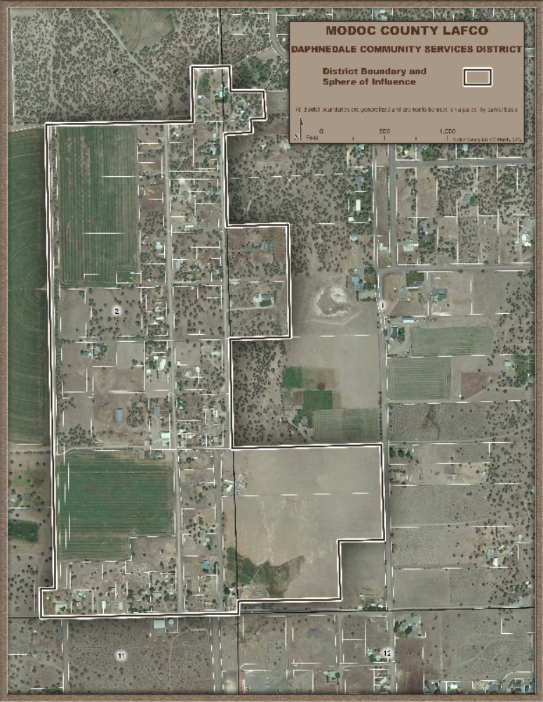

Remy, Michael H., Tina A. Thomas, James G. Moose, Whitman F. Manley, Guide to CEQA, Solano Press Books, Point Arena, CA, February 2007, page 111.
Modoc County Planning Department, Kim Hunter, Director, 203 W. 4th Street, Alturas, CA 96101, Phone: 530-233-6406, January 24, 2011.

